 **Christ Memorial Happenings**

**September 15th 2019**

**We Pray For**

Dr. Kristen Schmaltz, *Medical Missionary at Compassion Evangelical Hospital in Guinea, W. Africa* kmsguinea@gmail.com, Rev. Karim Baidaoui, *missionary to Muslims-Dallas-Ft. Worth,* Julie Aftab*, POBLO Missionary to international people in Houston*, Rev. Ken Bunge, *Lutheran* *Bible Translator*, Rev. Mark Seeger, *Deaf Youth Ministry of Texas*, Christ Memorial Early Childhood Learning Center children, parents & staff, leaders of our country.

*Those Serving in our Armed Forces*: Ben Adams, Juan Carlos Azofeifa, Alex Colon (Japan), Daniel Colon, John Hunter, Joe Kinney, Tim Martin (Japan), Junior Njoku

**Please pray for continual strength and healing:**

Norma Mills, Carl Nutzman, Rosemary Charles, Eunice Fritz, Rev. Don Peymann, Carol Stivers, Wanda Dearing, Jackleen Dohlman, Rob Brown, Dona Izzo, Cathy Townsend, Hee Kim, Linda Grant, Edna Gaisbauer, Claire Cook, Erica Griffiths, Brittany Steen, Maine Bertot, Rev. Darwin Bolyard, Kate Michalk, Ben Ladwig, Julie Johnson, Herb Michael, Dylan Powell, Emily Doss, Joyce Reddin, John Casey, Elaine Nelson, Dawn Alvarez, Laura Swinny, Amy Poppin, Glenda Pogue, Jen Mickan, Bethany Wilbanks, Anne Westerfield Brown, Judy McCabe, Suzanne Ultis, Rob Brown

**Please pray for those homebound or in nursing care:**

Estella & Jess Bryant, Evelyn Campbell, Verlie Hibbing, Carri Kirkpatrick, Betty McKinney, Ed Stickney, Lowell Kirkpatrick

**We Thank God For**

Our Guests who have come to worship with us.

**Sunday Prayers:** If you would like a prayer request included in the Sunday prayers, you may call the Church Office at 281-497-0250 or email michelle@christmemorialhouston.church.

Prayer requests for the CMLC Prayer Chain (that prays for special needs inside & outside the fellowship of Christ Memorial) may be given to Jennifer Hampton at 713-397-1329, emailed to [jennifero@yahoo.com](mailto:jennifero@yahoo.com) or written on an attendance card.

|  |  |
| --- | --- |
|  | On **September 29th** at our **Fifth Sunday Fellowship** all of us will have the opportunity to encourage some of our younger members.  Our two-year-olds who can now join Sunday School, our first graders who are learning to read God's Word and our first year confirmation students will be recognized.  Gift bags will be available for everyone to leave notes of encouragement for these young members.  All students are invited to bring their preschool bags and backpacks for a blessing of the school bags. |

|  |  |
| --- | --- |
| **Ushers & Worship Assistants** needed for both services. If you are interested and are a confirmed member (adult or young adult), please contact Robert Shindler: robertshindler@sbcglobal.net. |  |



**MAM Back to School Drive** Please consider sponsoring a child for MAM's Back to School Program. Just $50 can provide all the school clothes and accessories for one child to get the school year started. Donation envelopes are available with the posters in the Narthex and outside Fellowship Hall. Any amount is appreciated and needed. Just put your check or cash in the envelope and put it in our Offering Plates. Make check payable to **MAM Back to School**.

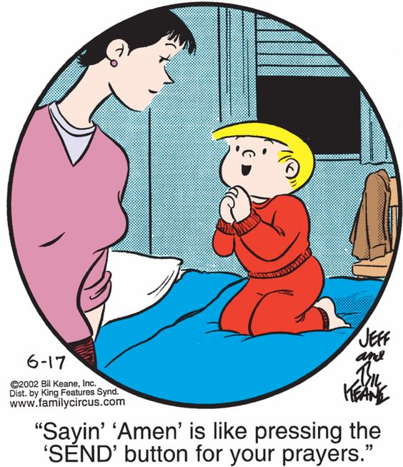

**Send announcements** to michelle@christmemorialhouston.church

|  |  |
| --- | --- |
| **The flowers today** are given in honor of George and Amelia Seibold’s wedding anniversary. |  |

|  |  |
| --- | --- |
| **CHOIR REHEARSAL Sunday evenings** from **6:30 to 8 pm** in the **Fellowship Hall**. The choir sings at the 8:15 worship services. We will be starting new music for fall and Christmas so this is a great time for new members to join! Anyone high school age and up is welcome! |  |



**Village Moms’ Bible Study** will meet **Tuesday, September 17th** at **9:30 am** in   
**A-112**.

**Tuesday Evening Lifelight Class September 17th** at **7:30 PM** in the **Upper Room** of the **Family Life Center**. We are studying the book of Romans. If you are interested in joining this study please contact Lyn or Les Schmaltz (281-813-5144).

**Youth Bible Time** The focus for 6th-12th grade students on **Wednesday, September 18th** is John the Baptist.  Meal begins at **6:30**, discussion at **7:00** in the **Youth Area**.  Questions? Contact Beth Shumilak 281-433-5414.

**Thursday Morning bible study** will meet on **Thursday, September 19th** at **9:30 am** in **A-112**. We will be starting a newvideo series– *Law of Love: Lessons from the Book of Deuteronomy.*

|  |  |
| --- | --- |
|  | **Women’s Care Group** will meet **NEXT SUNDAY, September 22nd from** **12-2 pm** in **A-112**. |

|  |  |
| --- | --- |
|  | **LADIES NIGHT** **Thursday, September 26th** starting at **6:30 pm** in the **Fellowship Hall**. All women are invited for dinner and dancing. Minou Pour will provide a homemade Persian main dish. If you wish, bring a side dish to share. Minou will demonstrate a Persian dance. If you have a favorite style of dance, pick a song or two and email it to Minou. Please RSVP to minoupour@gmail.com. |

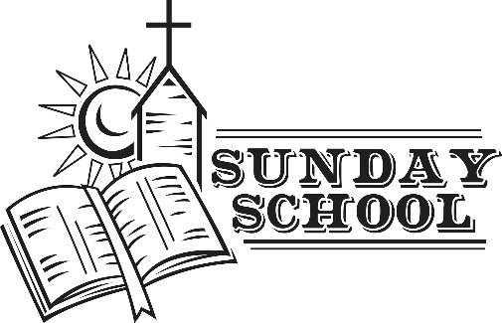

**Sunday School Classes – 9:30 am in the C & D Buildings**

|  |  |  |
| --- | --- | --- |
| **Opening** *(2-year-olds through 4th Grade)* | | D-204 |
| **Preschool** | Brittany Cliff/Barbara Temple | D-101 |
| **K-2nd** | Natalie Nassy/Lori Shumilak | D-102 |
| **3rd – 5th Grades** | Gail Klemp/Dan Monson | D-201 |
| **6th – 12th Grades** | Ed Shumilak/Linda Kelly | C-203 |

|  |  |
| --- | --- |
|  | Today’s lesson is THE FALL AND A PROMISE. The students will learn that God has redeemed us, sinful humans, through the Promised One, Jesus Christ. We can forgive others their sins against us because in Christ, God has forgiven us. Good questions for discussion include what things tempt us to sin and what consequences do we experience? |

***The Father has sent His Son to be the Savior of the world.***

***1 John 4:14***

**THIS WEEK AT CHRIST MEMORIAL**

|  |  |
| --- | --- |
|  | **Sunday – September 15th** |
| 8:15 am | **Worship** *with communion* |
| 9:30 am | **Sunday School** (*see classroom listing above*) |
| 9:40 am | **Bible Classes: *Pastor’s Bible Study*** – Fellowship Hall  ***LifeLight-Gospel of John***-Friendship Room  ***Matthew and Mark –*** A-112 |
| 10:45 am | **Worship** |
| 6:30 pm | **Choir Rehearsal – Fellowship Hall** |

|  |  |
| --- | --- |
|  | **Monday – September 16th** |
| 10:15 am | Rest Home Singers - Woodridge |

|  |  |
| --- | --- |
|  | **Tuesday – September 17th** |
| 9:30 am | Village Moms’ Bible Study – A-112 |
| 7:30 pm | Lifelight – FLC Upper Room |

|  |  |
| --- | --- |
|  | **Wednesday – September 18th** |
| 10:00 am | Bible Study – Edna Brown’s home |
| 6:30 pm | Youth Bible Time |

|  |  |
| --- | --- |
|  | **Thursday – September 19th** |
| 9:30 am | Bible Study – A-112 |

|  |  |
| --- | --- |
|  | **Saturday – September 21st** |
| 8:30 am | Men’s Breakfast Bible Study—Fellowship Hall |

|  |  |
| --- | --- |
|  | **Sunday – September 22nd** |
| 8:15 am | Worship *with communion* |
| 9:30 am | Sunday School & Adult Bible Classes |
| 10:45 am | Worship *with communion* |
| Noon | Women’s Care Group – A-112 |
| Noon | CREW Confirmation |
| 6:30 pm | Choir Rehearsal – Fellowship Hall |

**SERVING AT WORSHIP TODAY** **9.15.19**

|  |  |  |
| --- | --- | --- |
| *Preacher/Liturgist* | Pastor David Cecil | |
| *Organist* | Sue Early | |
| *Worship Team* | Luke/Pam Manning, Eric Utrecht, Danny Nguyen | |
| *Worship Assistants* | 8:15 | Ron Schroeder |
|  | 10:45 | Ed Shumilak |
| *Acolyte* | 8:15 | Colin Brogdon |
| *Lay Readers* | 8:15 | Lyn Schmaltz |
|  | 10:45 | Ed Shumilak |
| *Greeters* | 8:15 | David/Jennifer Hampton |
|  | 10:45 | Jake/Laura Carney |
| *Visitor Center* | 8:15 | Jim/Muriel Esposito |
|  | 10:45 | John/Patty Dasko |

**SERVING AT WORSHIP NEXT SUNDAY 9.22.19**

|  |  |  |
| --- | --- | --- |
| *Preacher/Liturgist* | Pastor Steve Simon | |
| *Organist* | Sue Early | |
| *Worship Team* | Luke/Pam Manning, Eric Utrecht, Danny Nguyen | |
| *Worship Assistants* | 8:15 | Mark Mayfield |
|  | 10:45 | Steve Volkers |
| *Acolyte* | 8:15 | Anton Pagaduan |
| *Lay Readers* | 8:15 | Karen Paul |
|  | 10:45 | Gabby Monson |
| *Greeters* | 8:15 | Bruce Koons |
|  | 10:45 | Patty Wolfe/Annie Kelly |
| *Visitor Center* | 8:15 | Jeff/Louise Nuttall |
|  | 10:45 | Frida Elias/Paul&Suzanne Ultis |

**September Ushers**

8:15: Ron Schroeder, Kirk Wright, Stephen Stakemiller, Trent Blake

10:45: David Richmond, Dan Monson & Family

**September Altar Guild:** Joan Giese

**September Counters:** Daniel Temple & David Richmond

